**Chapter 29 Magnetic Field**

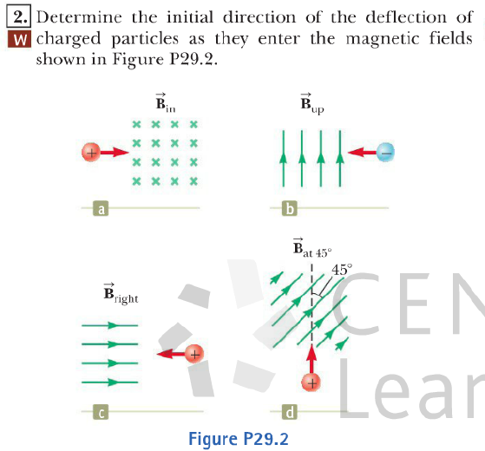

Answers: (a) Up. (b) Out of the page. (c) No deflection. (d) Into the page.

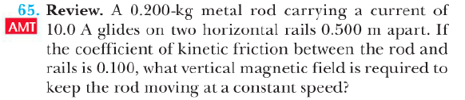

Answer: 